

<http://bravepeople.co/>

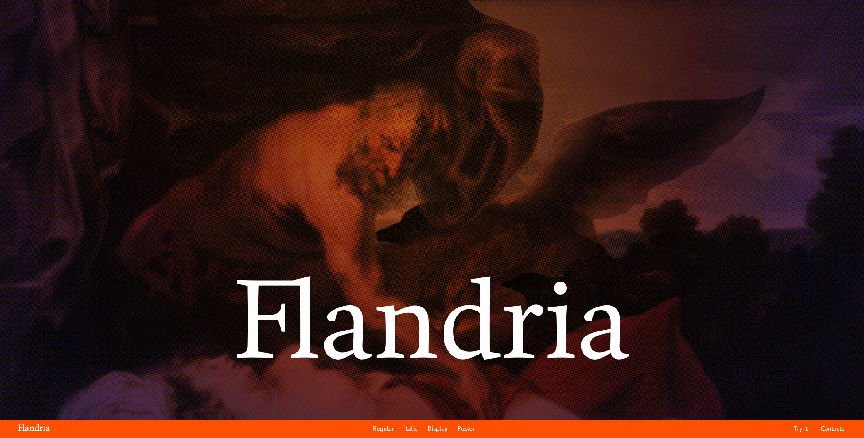

<http://www.flandriatype.com/>

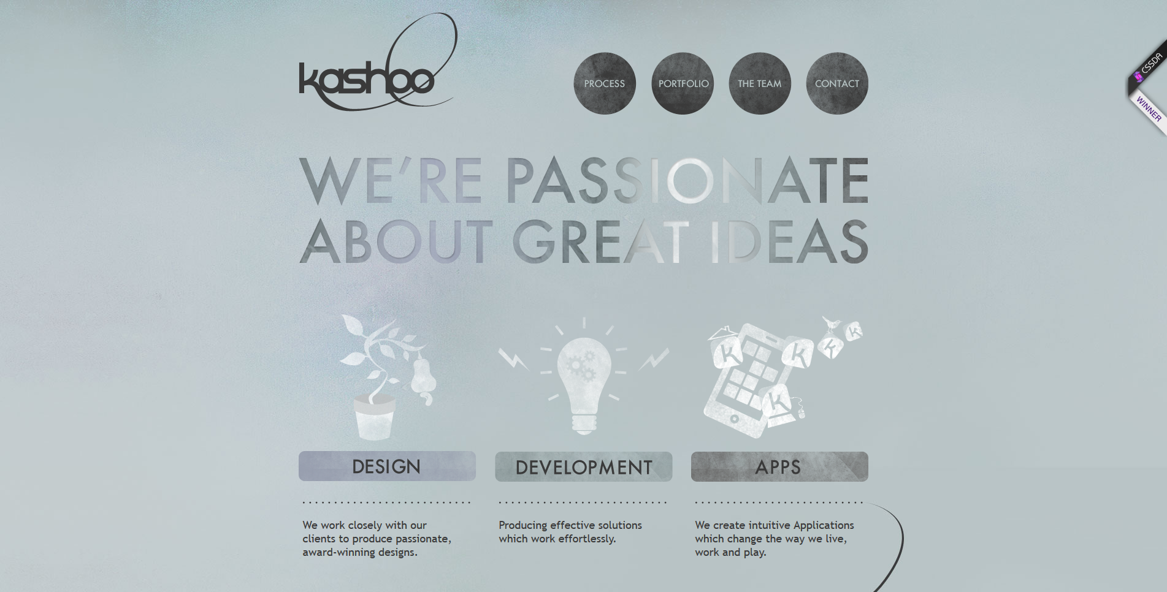

<http://www.kashoo.co.uk/>



<http://budoucnost.utb.cz/en/>